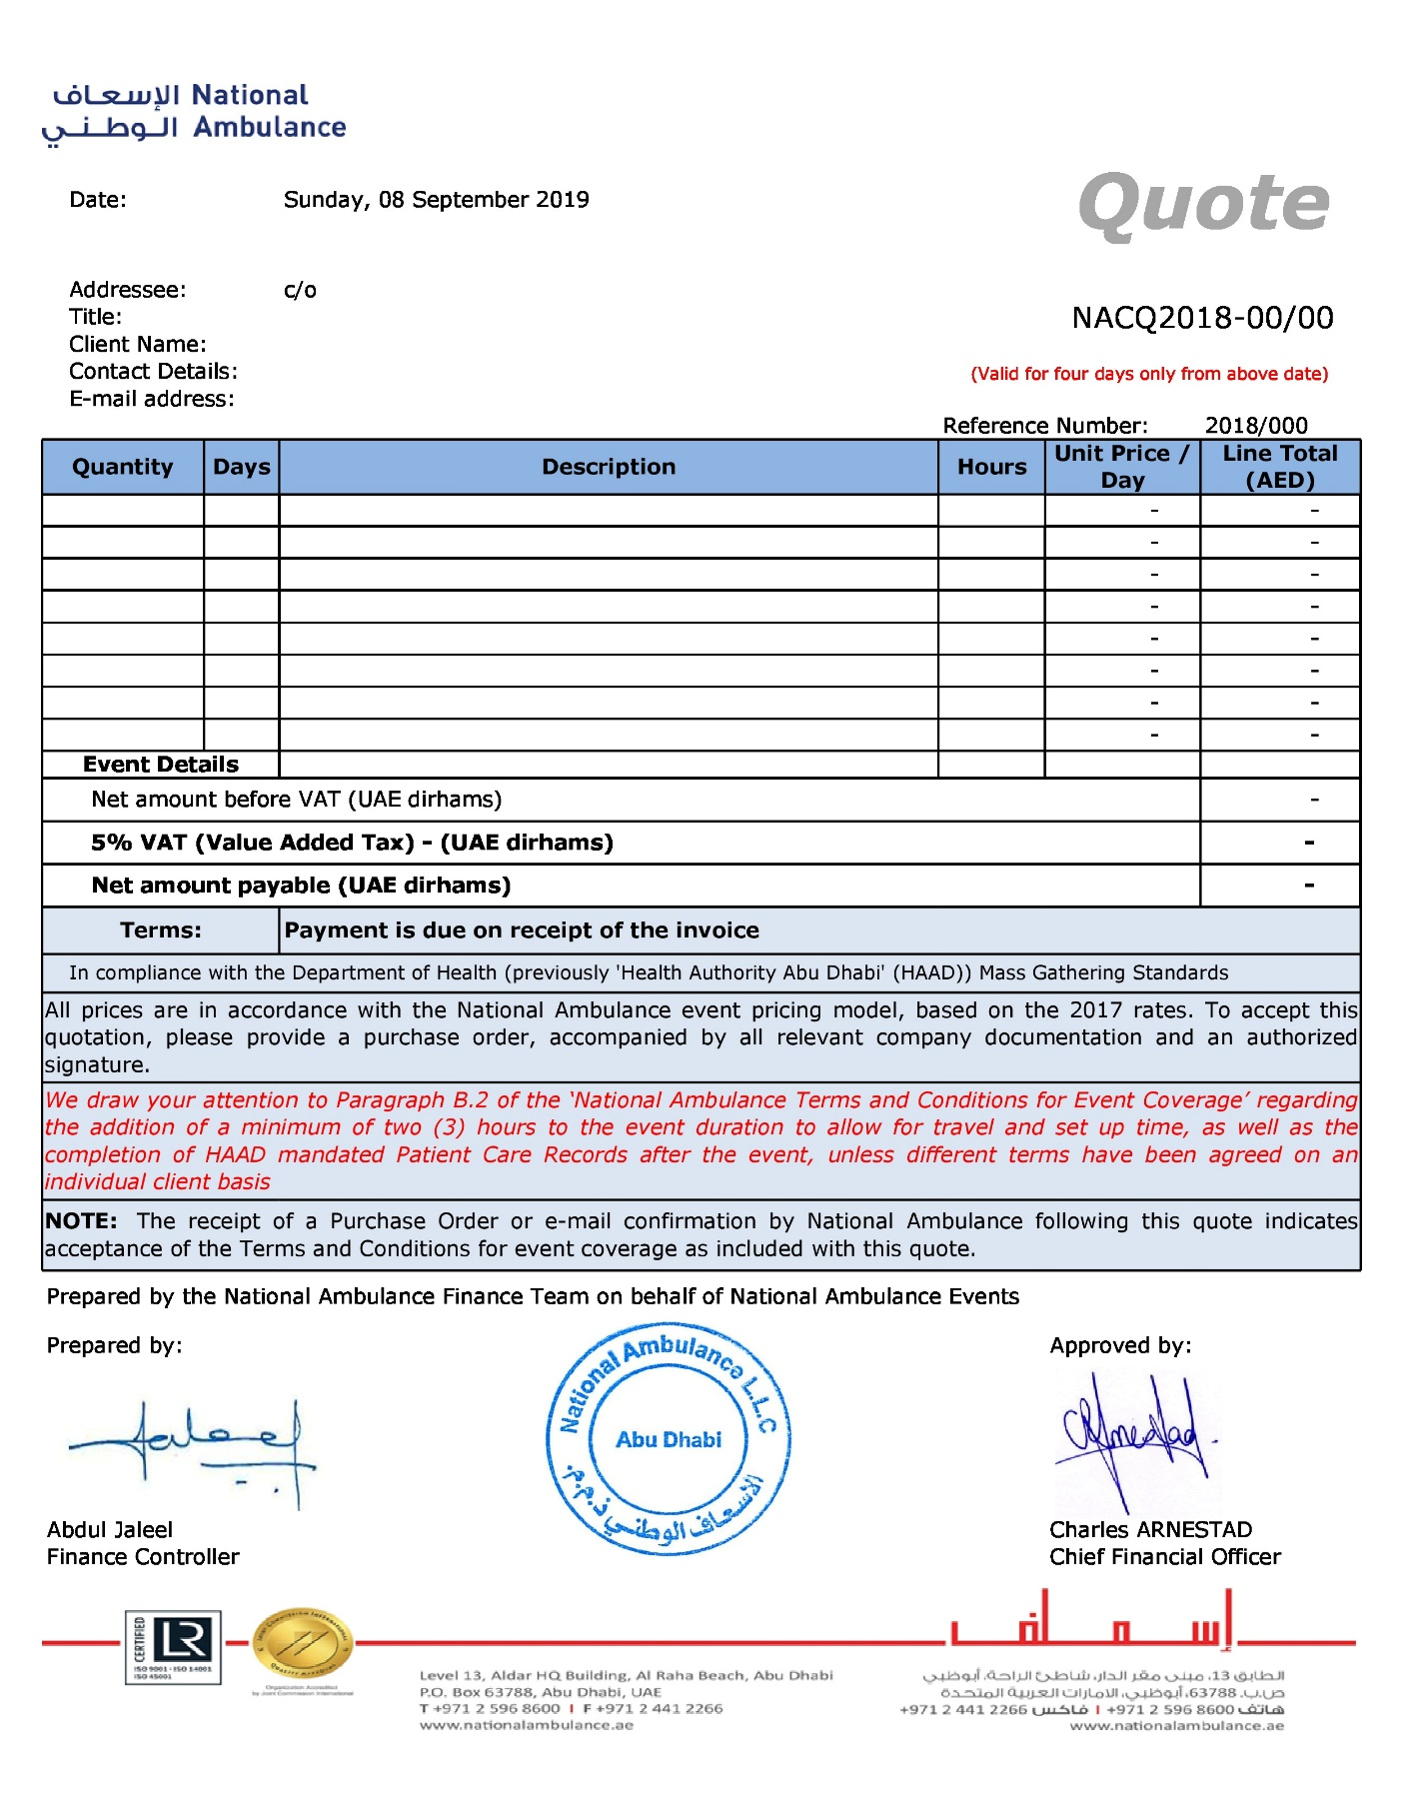

**National Ambulance – Terms and Conditions for Event Coverage**

These standard Terms and Conditions of Business are deemed to form part of the Agreement to provide pre-hospital care, into which they are expressly incorporated:

1. In these Standard Terms and Conditions of Business (the ‘**Terms and Conditions**’) the following terms shall have the meanings assigned below unless the context otherwise requires:
   * ‘**we**’ and ‘**our**’ refers to National Ambulance and ‘**you**’, ‘**yours**’ and the ‘**Client**’ refers to the party contracting with National Ambulance, jointly the **‘Parties**’. During the continuance of the agreement into which these Terms and Conditions are incorporated (the ‘**Agreement**’), we shall supply our services and you shall purchase the same subject to these Terms and Conditions. Definitions in the Agreement shall also apply in these Terms and Conditions.
2. The headings in these Terms and Conditions are inserted for convenience of reference only and are not intended to be part of or to affect the meaning or interpretation of any of the Terms and Conditions.
3. **Level of Cover:**
4. When we receive your request for pre-hospital care cover we will send you a pre-event form, which must be returned to us within ten (10) working days of the event.
5. A risk assessment, as mandated by the Health Authority Abu Dhabi (‘**HAAD**’), the ‘**HAAD Risk Assessment**’, will then be carried out by National Ambulance based on the information you have provided. Normally this will allow us to determine an appropriate level of cover for your event. This risk assessment does not absolve you of your own responsibility under the Health and Safety requirements to carry out your own risk assessment in connection with the event. Please note that the level of medical coverage will be determined by the information provided by the client upon returning to National Ambulance Events (‘**NAEvents**’) the ‘**Event Information Gathering Form**’. This level of medical coverage mandated by the HAAD Risk Assessment may differ from what is requested by the client. However, National Ambulance is obliged to provide the level of medical coverage as dictated by the HAAD Risk Assessment.
6. The issuing by National Ambulance of a quotation is not a binding offer and we will only assume the contractual liability once we have accepted in writing your confirmation that the quotation meets your requirements.
7. **Acceptance of Event Cover:**
8. Once we have determined the appropriate level of pre-hospital care cover, we will send a quotation to you based on the timings and duration of the event. Please note that there is a minimum charge equivalent to three (3) hours of cover. Should you wish to accept this quotation, please confirm your booking by e-mail to [events@nationalambulance.ae](mailto:events@nationalambulance.ae) within ten (10) working days of the event taking place. If we do not receive such confirmation within this period and you have not contacted us, we will assume that you do not wish to use our services and the event request will be canceled. Once we receive your e-mail confirmation, we will confirm by e-mail our acceptance of the event cover.
9. Please note that a minimum of two hours, depending on event location, will be added to the specified duration of the event. A minimum of one hour covers the National Ambulance travelling time and set-up time at the event. Another hour covers the wind-down time following the event, required for the completion of HAAD mandated Patient Care Records and the return of the National Ambulance crew to base.
10. **Refusal of Event Cover:**
11. Whilst we are committed to making every effort to assist you, we may also feel, after completing our risk assessment, that the event presents an unacceptable risk to our staff. In these circumstances we will advise you of our decision as soon as possible.
12. We may also be unable to assist you because of other commitments or the short notice period provided.
13. **Payment Terms:**
14. National Ambulance will invoice you in line with our original quotation unless additional cover has been provided or the level of cover has been varied.
15. If an event continues beyond the stated finishing time as agreed with you, cover will only be continued at the discretion of the National Ambulance event manager. If cover is extended by agreement, the invoice will be adjusted to include the additional duration at the standard hourly rate for that event.

3. Payment is due on receipt of the invoice.

1. **Charges for Late Cancellation:**
2. National Ambulance reserves the right to make a charge for cancellation at short notice as resources will already have been committed. No charge will be made if written cancellation is received by us at least five (5) working days before the event. If written cancellation is received at least three (3) working days before the event, 50% of the quotation is payable. If cancellation occurs less than two (2) working days before the event, 75% of the quotation is payable. If cancellation is made on the day, we reserve the right to charge for the full amount of the quotation.
3. **Your Responsibilities on the Day/s of the Event:**
4. As the organizer of the event you retain full responsibility for ensuring that a satisfactory risk assessment has been carried out for the event.
5. You must ensure that your event is properly controlled and that all risks to our personnel are minimized. In particular, you must comply with any request by our personnel to stop the event to allow necessary treatment and care to take place in safe conditions.
6. You must also advise us of any other contracted healthcare providers at the event and ensure that all additional personnel at the event are made known to our personnel before the event commences.
7. You must ensure that our vehicles have unrestricted access and exit from your site at all times.
8. You are responsible for ensuring that all necessary licenses to operate the event have been obtained and for compliance with all conditions associated with such licenses and in respect of all relevant legislation, regulations or similar. Failure to comply with the requirements of this clause may be treated by us as a fundamental breach of this Agreement, in which case we shall be entitled to immediately terminate the event. This will not affect our right to be paid for our services (whether performed or not).
9. Should the event be of such a size that you are using maps, plans and / or radio equipment, our personnel should be provided with the same. It is your responsibility to ensure an appropriate system / method of communication is made available to us.
10. **Our Responsibilities (and Limitations to the Same):**
11. We will provide pre-hospital care services at the event in a manner commensurate with good practice in pre-hospital care delivery.
12. You remain fully responsible for your event (see your responsibilities above).
13. It may be necessary for our personnel to leave the event in order to obtain further medical care for any person they are treating. We accept no liability should this mean that the event has to cease due to such a reduction of pre-hospital care cover.
14. Our event manager will be responsible for conducting the deployment of our personnel.
15. In the unlikely event of a life threatening situation occurring in the vicinity of your event, any ambulance at your event may be requested to respond (subject to reduced pre-hospital care provision remaining at the event). Should this occur, we reserve the right to leave the event without notice. We accept no liability for any losses you may incur due to the termination of the event, should the cause be due to our full or partial withdrawal.
16. In the unlikely event that insufficient personnel / equipment are available for your accepted event, we reserve the right to provide not less than 21 days’ notice to the named contact person on the pre-event booking form, of our intent to withdraw from the event. We also reserve the right to provide not less than 24 hours’ notice to the named contact person, of our intent to provide reduced resources. If the named contact cannot be reached, all reasonable effort shall be made to inform the appropriate organization in some other manner. It is the responsibility of the person booking our resources to ensure an appropriate system / method of communication is made available to us. We accept no liability for any losses you may incur due to the cancellation or reduction of the event for reasons as set out above.
17. In view of the circumstances specified earlier, you are advised to arrange appropriate ‘Event Cancellation’ insurance. We will not accept liability for any loss which you incur in relation to cancellation which could have been covered by such insurance.
18. Neither National Ambulance nor our personnel shall be liable, under any circumstances, for any damage to land or property in the event of access being required to a casualty or to allow egress from a site.
19. Subject to the clause below, neither we nor our personnel shall have any liability to you or any third party, for any loss, expense or damage of any nature, suffered or incurred arising from any breach of any condition of the agreement or any negligence or any breach of statutory or other duty or in any other way in connection with performance or purported performance of or failure to perform the agreement.
20. Nothing in this Contract shall be taken to exclude liability for death or personal injury resulting from our (or our personnel’s) negligence.
21. We shall not be liable for any failure in performance of any of our obligations under the agreement caused by factors outside of our control (including but not limited to fire, storm, flood, etc.).
22. **Information Provided by and to National Ambulance:**
23. If, in our opinion, a suitable level of cover cannot be agreed, we reserve the right not to proceed with our services. It remains, however, your sole responsibility as the body organizing the event to ensure that the level of cover requested complies with all statutory regulations and requirements laid down by any governing body relating to such event.
24. Acceptance of all events, and the fees quoted, for the provision of resources is made on the understanding that the details of the event submitted to us are accurate and correct. If we are notified of changes to these details, such as levels of resources, duration, time or location of event, we reserve the right to revise our fees, or to reconsider our acceptance of the event. If, upon arrival at the event, the National Ambulance event manager considers the event to be larger or of a higher risk than stated on the booking form or subsequent correspondence, we reserve the right to withdraw from the event. In such circumstances all reasonable effort shall be made to advise the contact name on the booking form of the reasons for withdrawal. Should it be necessary at this stage to withdraw from the event, full charges will apply for the resources provided, and we accept no liability for any loss you may incur due to the termination of the event in such circumstances.
25. Details of persons treated by National Ambulance personnel, and their personal information, will only be provided upon a request by legal representation and / or by written consent of the individual concerned.
26. **Entire Agreement, Amendment, Waiver:**
27. This Agreement, these Terms and Conditions and the documents referred to therein contain the entire agreement between the Parties and supersede any previous agreement between them relating to the subject matter of the Agreement, whether written or oral. The Parties acknowledge that neither of them has relied upon any representation, written or oral, of any person but only as expressly set out in the Agreement.
28. Any valid alteration to or variation of the Agreement must be in writing and signed on behalf of each of the Parties by a duly authorized representative.
29. No failure of either party to enforce at any time or for any period any term or condition of the Agreement shall constitute a waiver of such term or of that party's right later to enforce all terms and conditions of the Agreement.
30. **Severance:**
31. If any provision of the Agreement or these Terms and Conditions is declared by any judicial or other competent authority to be illegal, void, voidable or otherwise unenforceable, or indication of the same is received by either of the Parties from any relevant competent authority, such provision shall be deemed severed and the remaining terms shall remain in full force and effect.

1. **Confidential Information:**
2. The Parties agree to treat as secret and confidential and not, at any time for any reason during or after the termination of the Agreement, to disclose or permit to be disclosed or made use of any confidential information concerning the other's business customers, suppliers or associated companies which they may acquire in the course of the Agreement or any other information expressly identified as confidential information in these Terms and Conditions. For the avoidance of doubt, the restrictions in this term shall not prevent:
   * The disclosure or use of information in the proper performance of our duties.
   * The disclosure of information if required by law, or the disclosure of information which is already in the public domain otherwise than through unauthorized disclosure by National Ambulance or the Client.
   * Nothing in the agreement shall prevent National Ambulance from using the Client’s name in any list of clients used by National Ambulance for its own promotional purposes unless the Client has notified National Ambulance in writing that it is unwilling for its name to be so used.
   * The provisions of this term shall survive the expiry or termination of the agreement.
3. **General:**
4. The Parties to this contract do not intend that any of its Terms and Conditions will be enforceable by virtue of the contracts by any person not a party to it.
5. **Complaints:**
6. Any complaints or disagreements regarding our services or those of our personnel should be taken up with the event manager at the event. If the issue cannot be resolved, all complaints must be made in writing to National Ambulance Head Office, care of the Director of Quality and Improvement at PO Box 63788, Abu Dhabi, United Arab Emirates.
7. **Law and Jurisdiction:**

This Agreement shall be governed and construed pursuant to the Federal and local laws applicable to the United Arab Emirates, as applied in the Emirate of Abu Dhabi.